Project Initialization and Planning Phase

Date | 30 September 2026
Team ID | SWTID-2026-9794
Project Name | AI BlogNest API
Maximum Marks | 3 Marks

Define Problem Statements (Customer Problem Statement Template):
Create a problem statement to understand your customer's point of view. The Customer Problem Statement
template helps you focus on what matters to create experiences people will love. A well-articulated customer
problem statement allows you and your team to find the ideal solution for your customers' challenges. Throughout the process, you’ll also be able to empathize with your customers, which helps you better understand how they
perceive your product or service.

Example:
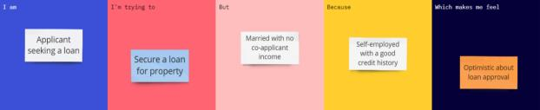

Problem  Statement  (PS) | I am  (Customer) | I’m trying  to | But | Because | Which makes  me feel
PS-1 | A student or content creator who wants to write a blog. | Create an interesting and quality blog easily | I find it difficult to generate ideas and write good content. | I may lack writing skills, time, and creative ideas. | Confused and frustrated while creating blogs.

